welcome – services – portfolio – trade & clients – connect with us

“WELCOME” page (carrousel pictures)
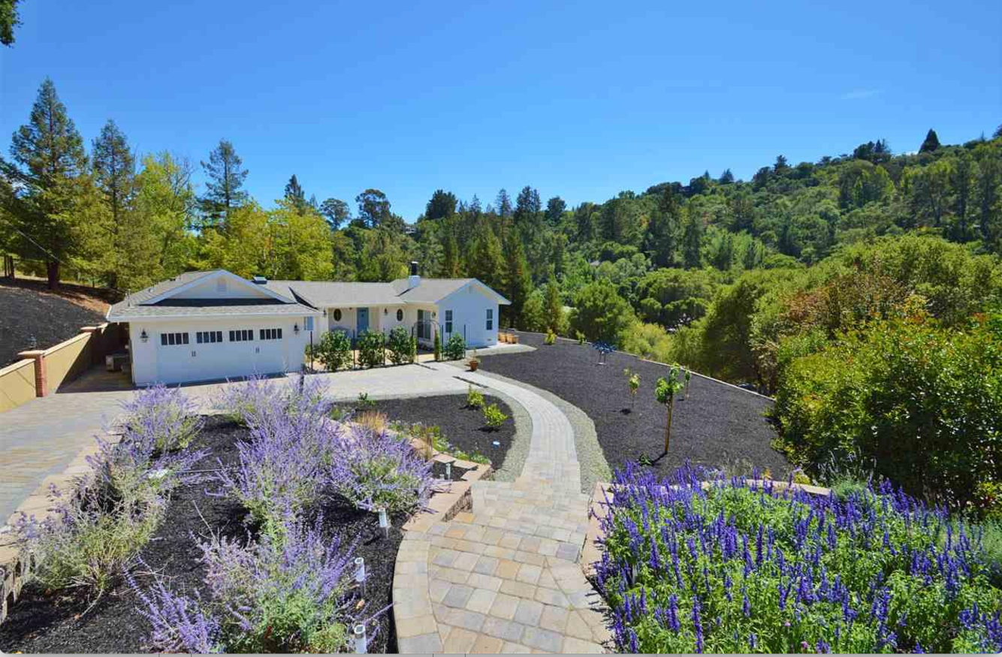

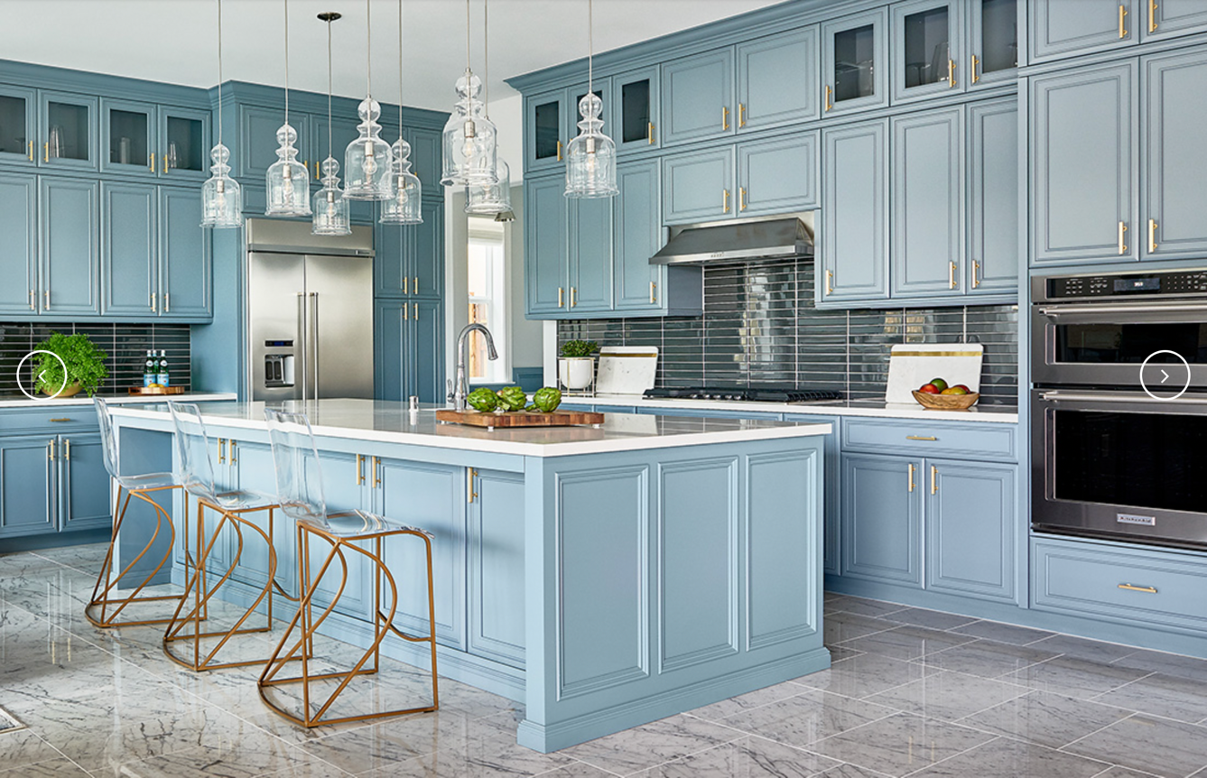
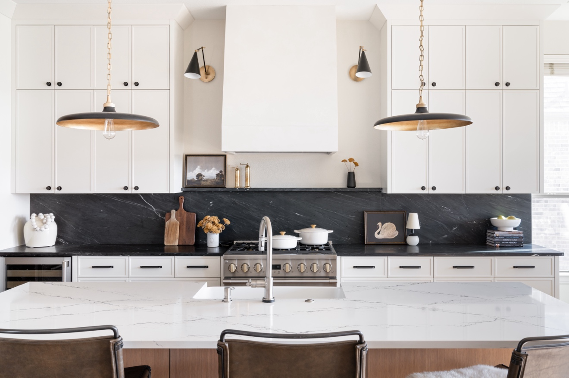

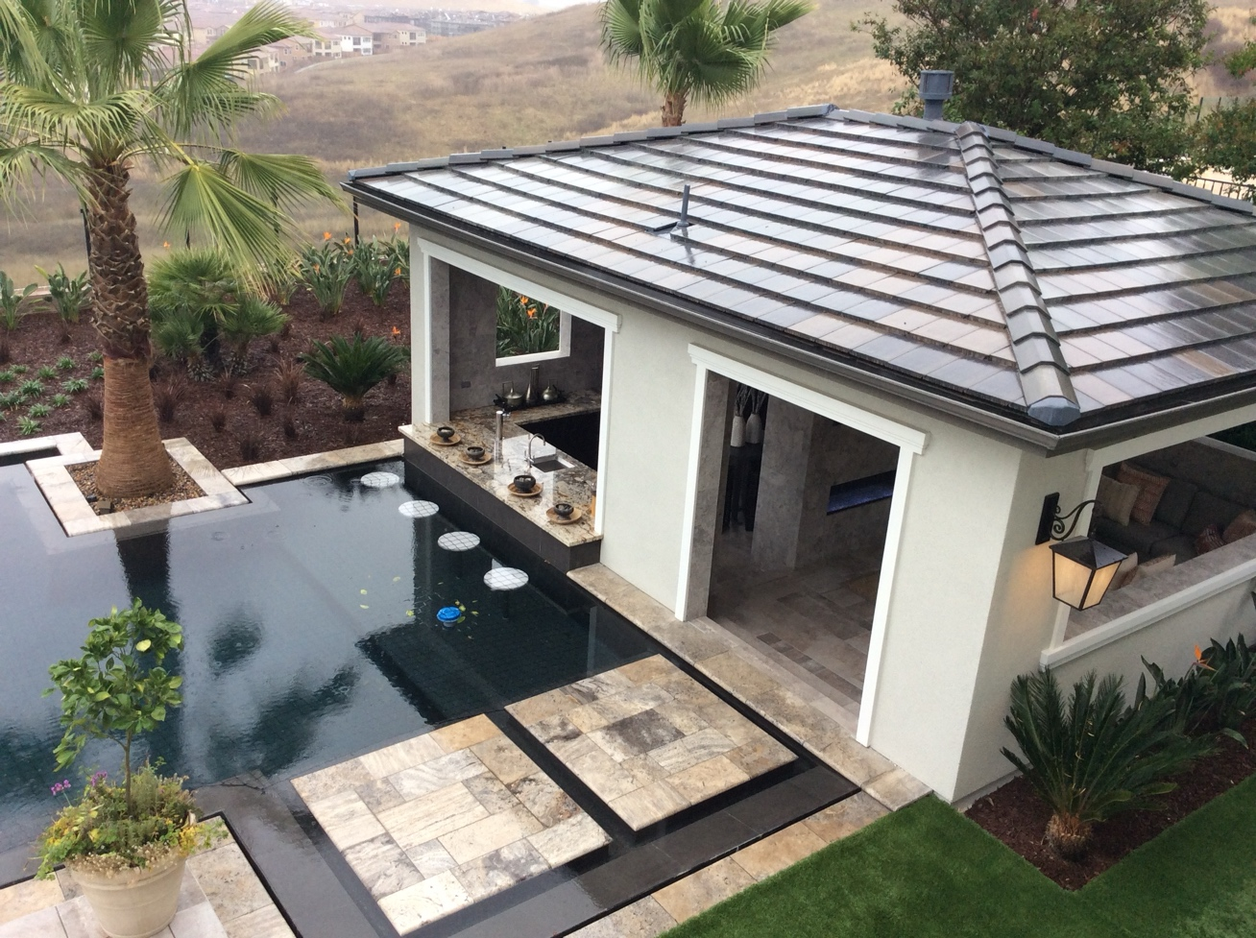

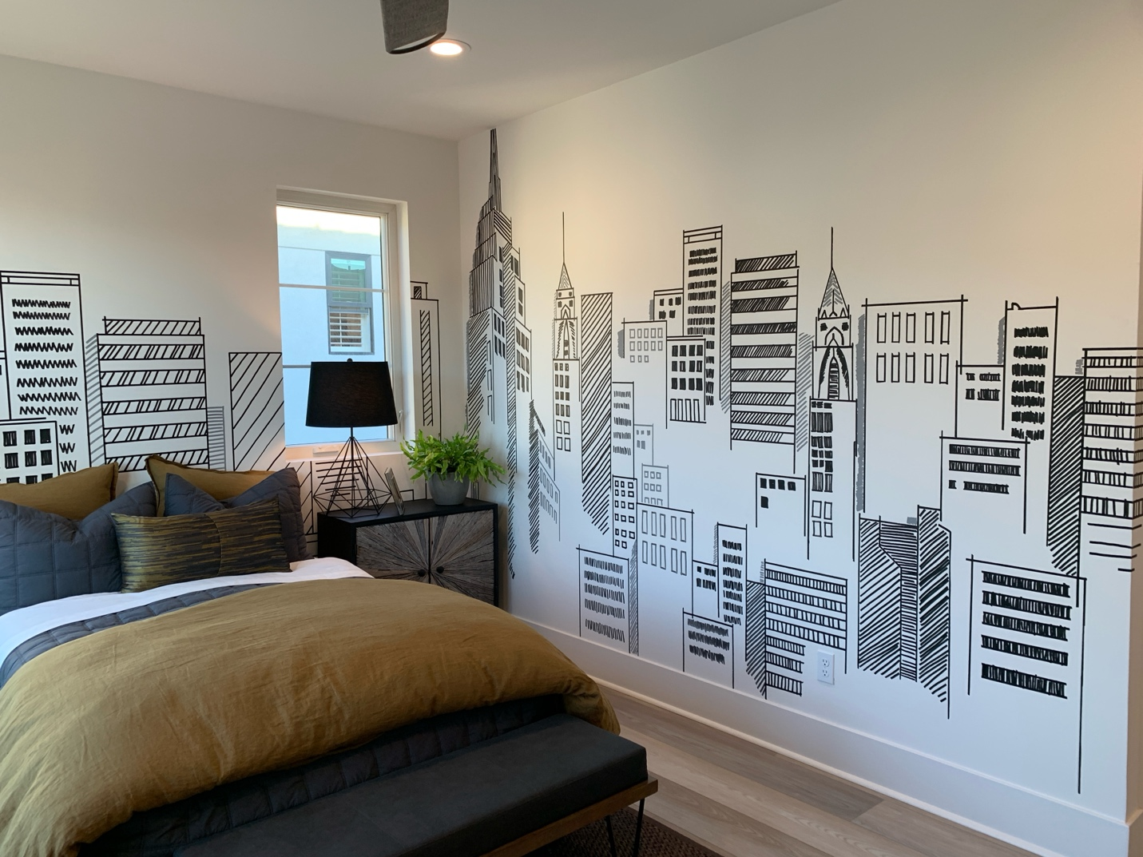

The banner in the middle of the pictures will say: BUILD YOUR HAPPY!

Our commitment to honoring each client's distinct personal style breathes life into every home we touch. From new build, a small or complete renovation, to simple design consultations, we bring your vision to reality with precision and flair. Whatever your needs are, we're here for it!


(the button above takes the client to the “Connect With Us” page)

WHAT WE DO

At Green Brick Builders, we are committed to ensuring that your home is a true reflection of your unique style and personality. We honor the individuality of each client, approaching every project with innovative thinking and a time-tested methodology. We know the process can be overwhelming, from understanding architecture, exploring design styles and most importantly trusting a contractor to guide you through the journey. You start researching options and are bombarded with price differences, choices, timelines, and the number of contractors saying they are up to the task – how do you decide?
This is where we come in. We aim to make the remodeling/building process enjoyable and pride ourselves on being approachable and easy to work with - we collaborate closely with our clients on a personal level to create highly customized, functional, and inspiring spaces that elevate everyday living.
We can’t wait to be a part of your team!

REVIEWS wheel:

“LOVE, LOVE, LOVE, “I TRULY FELT LOOKED
GREEN BRICK BUILDERS! AFTER THROUGHOUT
THEY’VE BEEN NOTHING THE WHOLE PROCESS
BUT A PLEASURE TO AND FEEL LIKE CRISTINA
WORK WITH.” WENT ABOVE AND BEYOND.”

Samantha L. Rory R.

“VERY CREATIVE, STAYED “GREEN BRICK BUILDERS
WITHIN MY BUDGET, AND DESIGNED AND BUILT OUR
NOW MY PLACE LOOK 1,100 SF. WE WERE
STUNNING.” THRILLED WITH THE WAY
IT TURNED OUT.”
Cristiane B.
Sam D.

“I BOUGHT A BUNGALOW “THE COMPANY CAME
AND CRISTINA REDESIGNED HIGHLY RECOMMENDED
IT. IT TURNED OUR SO TO ME BY A FRIEND AND
ADORABLE. I WAS THRILLED THEY MET ALL MY
WITH THE RESULTS.” EXPECTATIONS.”

Doreen M. Alexis. V.

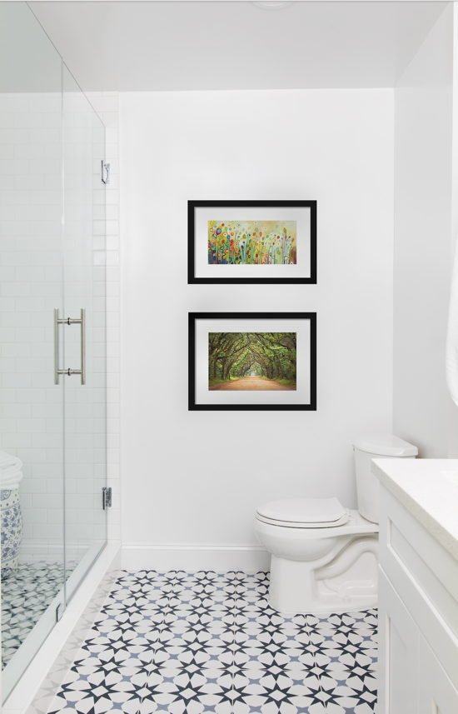

This button takes the viewer to the “Our Services” page
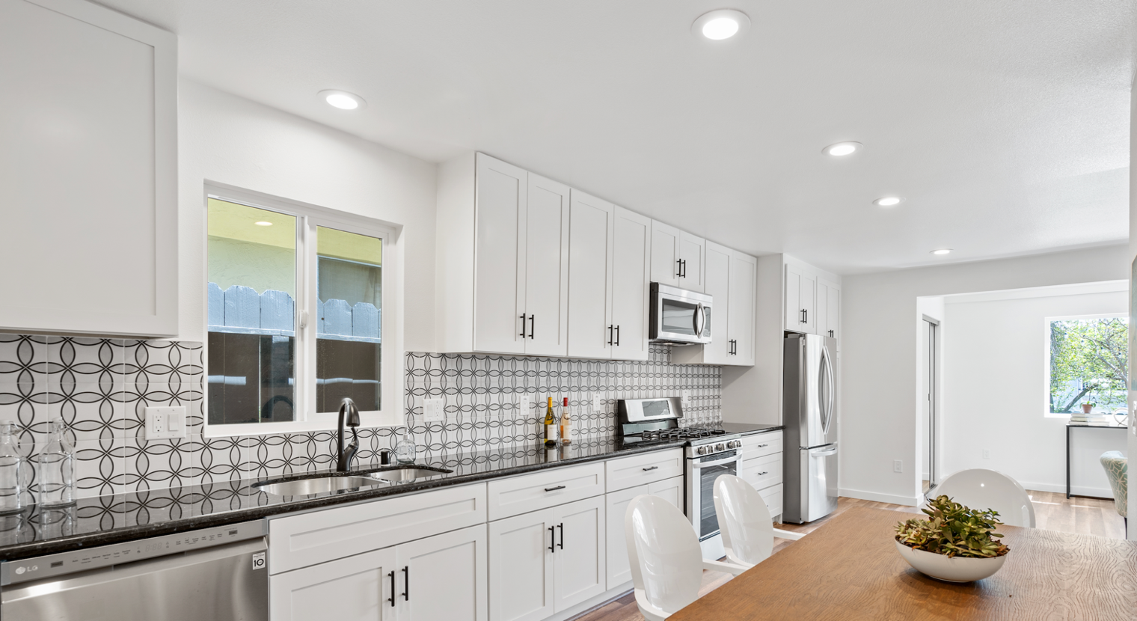

The icons from the associations we are a part of will go on top of the picture above in a wheel just like the inspiration website.

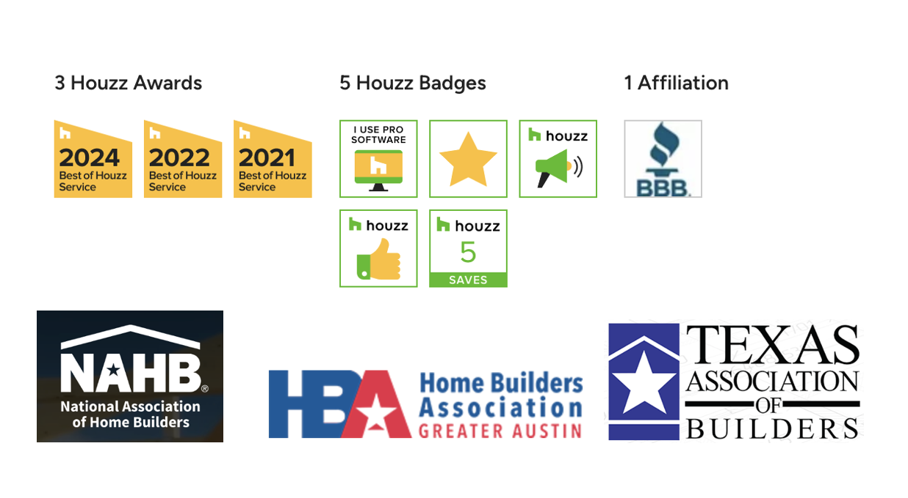

I will send you the files for the applications above in a separate email.
Address for the footer:

4412 Spicewood Springs Suite 106 Mon-Fri 9am to 5pm
Austin TX 78759 Sat 9am to 1pm

1 (512) 337-3636

@greenbrickbuilders TM
